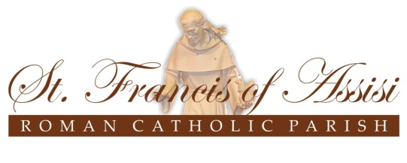

October 13, 2021
CONFIRMATION REGISTRATION

Dear Parents / Guardians of Children Currently in Grade Seven (2021 – 2022 School Year),

I hope you are safe and healthy at this challenging time. I wanted to reach out to let you know that nurturing the faith of our young people and their families remains a top priority for the parish.

Working closely with you and our school administrators and teachers, I will do my best to prepare your children for the Sacrament of Confirmation in the coming months.

With that in mind, I am inviting you to attend a REGISTRATION and INFORMATION MEETING for Confirmation at St. Francis of Assisi Church, 2473 Thorn Lodge Drive, Mississauga, on ONE of the following dates:

Thursday, November 4, 2021, at 7:00pm
OR
Saturday, November 6, 2021, at 10:00am

These meetings are intended for parents and Confirmation candidates, and even though I strongly encourage both parents to attend, I certainly understand if only one parent can come so the other is able to remain at home with young children.

You are asked to bring to the meeting a completed registration form (see attached) and a PHOTOCOPY of the Catholic baptismal certificate of your child who is preparing for Confirmation, along with $50 (cash or cheque), which is the registration fee. All of these items must be submitted at the church by the end of the meeting in order for your child’s registration to be complete.

Each Confirmation candidate will be asked to choose a sponsor to offer spiritual support on his or her faith journey. The Sponsor Declaration Form included in this package is to be completed by your child’s Confirmation sponsor. If the sponsor lives nearby and the completed form can be turned in at the Registration Meeting, that would be very much appreciated, but the Sponsor Declaration Form may be submitted at a later date if that is more convenient.

I look forward to seeing you at one of the Registration and Information Meetings later in October. If you have any questions or concerns, please call the Parish Office (905) 822-8132 and speak to
Melinda, the Office Administrator, or myself, Fr. Damian. We will do our best to help you any way we can.

Yours sincerely,

Reverend Damian S. Ali,
Pastor

