TWENTY-THIRD SUNDAY IN ORDINARY TIME
September 5, 2021

True Beauty and Goodness Come from Within

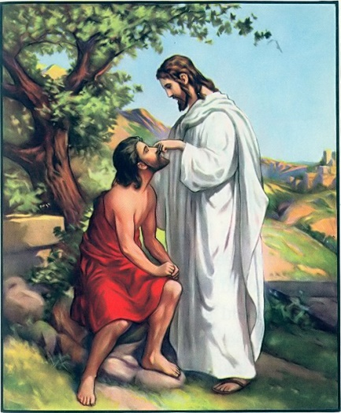
How do you expect the Lord Jesus to treat you when you ask for his help? Do you approach with fear and doubt, or with faith and confidence? Jesus never turned anyone aside who approached him with sincerity and trust. And whatever Jesus did, he did well. He demonstrated both the beauty and goodness of God in his actions.
The Lord's touch awakens faith and brings healing
When Jesus approaches a man who is both deaf and a stutterer, Jesus shows his considerateness for this man's predicament. Jesus takes him aside privately, not doubt to remove him from embarrassment with a noisy crowd of gawkers (onlookers). Jesus then puts his fingers into the deaf man's ears and he touches the man's tongue with his own spittle to physically identify with this man's infirmity and to awaken faith in him. With a word of command the poor man's ears were opened, his tongue was released, and he spoke plainly.
What is the significance of Jesus putting his fingers into the man's ears? Gregory the Great, a church father from the 6th century, comments on this miracle: "The Spirit is called the finger of God. When the Lord puts his fingers into the ears of the deaf mute, he was opening the soul of man to faith through the gifts of the Holy Spirit."
The transforming power of kindness and compassion
The people's response to this miracle testifies to Jesus' great care for others: He has done all things well. No problem or burden was too much for Jesus' careful consideration. The Lord treats each of us with kindness and compassion and he calls us to treat one another in like manner. The Holy Spirit who dwells within us enables us to love as Jesus loves. Do you show kindness and compassion to your neighbors and do you treat them with considerateness as Jesus did?

Lord Jesus, fill me with your Holy Spirit and inflame my heart with love and compassion. Make me attentive to the needs of others that I may show them kindness and care. Make me an instrument of your mercy and peace that I may help others find healing and wholeness in you.

SUNDAY MASS ON YOUTUBE
Mass is being live streamed on our Parish YouTube Channel on Sunday morning beginning at 10:00 a.m. and every Wednesday at 7pm (preceded by the Rosary at 6:40pm).
The link to our parish YouTube channel is:
https://www.youtube.com/channel/UCokoBfidkSQAZ_Buk3g-bhw?

RECONCILIATION
The Sacrament of Reconciliation (Confession) is offered every Saturday from 4:00pm to 4:45pm in the Reconciliation Room of the church.

2021 FEDERAL ELECTION: CATHOLICS & CANADIAN POLITICS FT. JOHN MILLOY
Catholic Conscience presents a free webinar as part of their Catholic Action initiative in the 2021 federal election campaign: Federal Election 2021: Catholics & Canadian Politics featuring John Milloy. In a wide-ranging conversation at the apex of the 2021 federal election, we will discuss the past, present, and future of Catholic political engagement at the federal level.
Join us for this free webinar on Wednesday, September 15th at 7 p.m. EDT. RSVP on Eventbrite for login details: https://bit.ly/CatholicsAndCanPoli

MONDAY, SEPTEMBER 6 – 10:00 A.M.
S.I. Janet Tan
S.I. Tiana Ragno
S.I. Cynthis Wolf
TUESDAY, SEPTEMBER 7 – 8:30 A.M.
+ Francesca D’Oliveira
S.I. Julian Noronha
S.I. In celebration of family birthdays.
WEDNESDAY, SEPTEMBER 8 – 7:00 P.M.
+ Purissima Melchiorre
+ Rolando Raymundo
+ Margaret Somers
THURSDAY, SEPTEMBER 9 – 8:30 A.M.
S.I. For married couples and those preparing for marriage.
FRIDAY, SEPTEMBER 10 – 7:00 P.M.
+ Francisco Silang
+ Mary Smith
S.I. In thanksgiving for blessings received.
SATURDAY, SEPTEMBER 11 – 5:00 P.M.
+ Joan Quigg
+ Miguele and Assunta Renzullo
S.I. Richard and Celissa Noronha
SUN., SEPTEMBER 12 – 24TH SUNDAY IN ORDINARY TIME
S.I. Parish Community

Our parish now has a subscription to FORMED, a premier online platform. Best of all, this material is free to you.
There are 3 easy steps to Sign Up on FORMED:
- Visit http://signup.formed.org/
- Enter our parish code: L5K
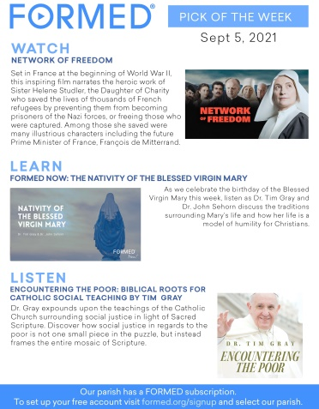
- Enter your name and email

CHURCH BULLETIN ADVERTISING
Liturgical Publications will be setting up the advertisements for our church bulletin. The advertising will begin in September 2021 and supports the bulletin service. Please support the bulletin and advertise your product or service. Call Liturgical Publications at 905-624-4422.

MASS TIME CHANGE
Please note that effective Tuesday, August 3, morning Masses on Tuesdays and Thursdays will begin at 8:30 a.m.

50th ANNIVERSARY OF THE FOUNDING OF
ST. FRANCIS OF ASSISI PARISH, MISSISSAUGA
1971-2021
September 8th, 2021, will mark a significant milestone – the 50th anniversary of the founding of our parish! The last 17 months have been hard on all of us, so it is a blessing that we have something special to celebrate. Even though pandemic restrictions will not allow for an elaborate social gathering or a reception in the parish hall, I am truly grateful that Bishop Ivan Camilleri has graciously agreed to preside and preach at the 7:00pm Mass on Wednesday, September 8th.
On the universal Church calendar, September 8th is also the Feast of the Nativity of the Blessed Virgin Mary. On this very special occasion, let us ask our Blessed Mother for her continued protection and for the grace to faithfully serve her Son, Jesus Christ, as we embark on a new and exciting segment of our faith journey.

WORLDWIDE MARRIAGE ENCOUNTER
Discover the possibilities of a marriage lived as God intends it! Join us for the weekend ON October 22-24, 2021 for a Virtual/Online Worldwide Marriage Encounter Experience
Live your best life in love! Restore your loving communication with your spouse and rekindle the romance. The Marriage Encounter experience is a skill-building enrichment program where you, as husband and wife, learn how to be the best couple you can be; a special weekend to spend in ways that normal, daily living tends to inhibit. No group discussion. Based on Catholic values but open to couples of all faiths. Rediscover the love in your relationship! Contact: Marge & Gerard McCauley at gerard.marge@rogers.com or (905) 792-1925 Website: wwme.org

